Dear Guests,

I am delighted to be welcoming you to the 23rd ALMR Christmas Lunch.

And what another transformational year it has been, politically, commercially and for your

Association too: a coming of age. With our membership now covering 90% of managed

pub, bar and branded restaurants, it is the year we can truly claim to have delivered

a strong and effective voice for licensed hospitality at the heart of government. The

successes we have achieved on your behalf are testament to the power that comes from

having one united voice.

The ALMR Christmas Lunch is a very real symbol of that unity – the largest and best

attended of all the industry events it celebrates the diversity, vibrancy and dynamism of

our sector. How much we have changed over the last 23 years and how significant our

contribution is when we come together. It is also writ large what you as operators do so

well each and every day; bringing people together. It is about the moment of theatre at

the heart of the everyday.

And so it is right that today is about celebrating and recognising the value of an industry

of which we are justifiably proud – and, most important of all, the people within it who

make it.

This year The ALMR is also reflecting on a dramatic and successful, 25 years as the number one Trade Association for the Hospitality Industry. We are in a great position to represent all our members and pushing for government support to enable businesses to grow and succeed. Here’s to the next 25 years for what will, no doubt, be another eventful and constantly – evolving period for the country’s dynamic going out sector.

To our members and partners, I would like to say a huge thank you for your support,

contribution and engagement throughout the year. It has been essential in building the

reputation and influence this sector has at the highest levels.

There are many exciting challenges and new initiatives for 2018 and beyond and I can’t

wait to see what we can all achieve together.

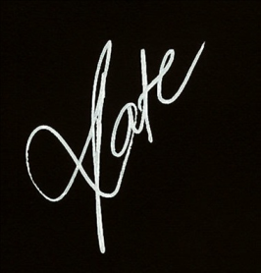

Kate Nicholls

Chief Executive